4th July, 2017

**Press Release: David takes the Bull by the horns in his new role**

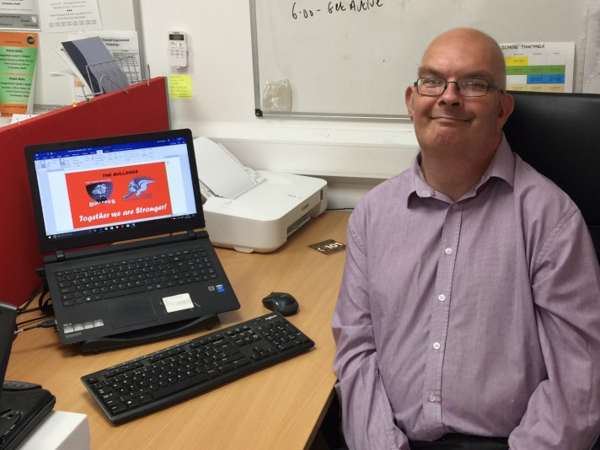David Cooper, 46 from Port Talbot had previously worked as a civil servant but had to finish to care for his aging parents. David cared for his parents for 15 years and when the time came to return to work David wasn’t quite sure where to begin. He had lost a lot of confidence over the years and technology had advanced in this time. David suffers with Spina Bifida Occulta and arthritis of the spine and legs which restricts the jobs he is able to do.

David contacted Workways+ in August 2016 after seeing a news story on the internet promoting the project. David was assigned a mentor, who listened and took time to understand the factors that were preventing him from finding work. David’s mentor placed him on courses which helped him rebuild some of the skills and confidence he felt he had lost over the years. One of these courses was an accredited administration course which gave David something up-to-date to put on his CV. His mentor also helped him find a work experience placement which gave David the opportunity to practice some of the skills he had learned on the administration course and gave him a taste of being back in work.

At the end of the work placement, David was keen to develop his skills and keep up the routine he had established. David and his mentor discussed volunteering opportunities and the options available to him to help him to improve and update his skills. After considering a couple of options David began volunteering at The Bulldogs, a charity that delivers community based activities focusing on boxing as a sport. David has been volunteering now for four weeks and is enjoying the experience.

David said “It is helping my confidence and giving me the opportunity to meet people. I think doing this will give me the confidence to apply for jobs in the future. The staff here at The Bulldogs have really welcomed me into the team, I am enjoying being back in an office environment and enjoying the work and learning new IT skills.”

David continues to work with his mentor at Workways+ with the longer term aim of progressing into paid employment.

Councillor Rob G. Jones, Leader of Neath Port Talbot Council said “I am delighted once more to see the continuing success of Workways+ and I would like to congratulate David on his dedication and commitment to getting that step closer to attaining his goal of full term employment.”

Workways+ is backed by £7.5m of EU funds through the Welsh Government. The project is led by Neath Port Talbot County Borough Council in collaboration with Swansea, Carmarthenshire, Pembrokeshire and Ceredigion Councils.

**ENDS**

For more information or to arrange an interview, please contact Nerys Griffiths on (01639) 684250 or email [n.griffiths1@npt.gov.uk](mailto:n.griffiths1@npt.gov.uk)

Notes:

1. Image: David Cooper in his work placement at Bulldogs Boxing Community Activities
2. Workways+ offers training and paid work experience opportunities to long-term unemployed people to help them on their route back to employment. Backed by £7.5 million of EU funds, the three-year scheme will benefit people in Neath Port Talbot, Swansea, Carmarthenshire, Pembrokeshire and Ceredigion.
3. The Bulldogs formed to give the next generation of young people from Port Talbot and its surrounding areas, a fighting chance in life. Many young people face barriers and challenges in their everyday life. At The Bulldogs we aim to support them in making positive choices and changes to develop into responsible citizens. The Charity delivers our community focussed activities whilst the Boxing Club delivers the sport.