West Glamorgan Safeguarding Board

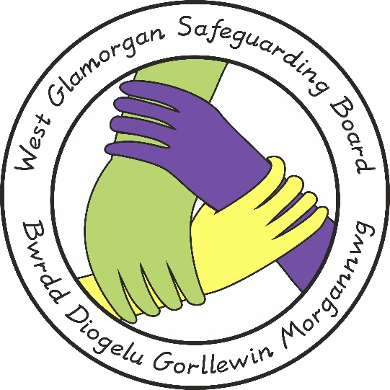

WGSB Non-Recent (Historical) Abuse

Document Author: Policy, Practice & Procedure Management Group
Approved by: WGSB
Issue Date: 16 June 2021
Review Date: 16 June 2024

- Introduction
It is not unusual for people to disclose experiences of physical, sexual and / or emotional abuse and / or neglect which constitute significant harm only when they reach adulthood.

Organisational responses to allegations made by an adult of abuse experienced as a child must be of as high a standard as a response to current abuse because:
- There is a significant likelihood that a person who abused a child/ren in the past will have continued and may still be doing so;
- Criminal prosecution may be possible if sufficient evidence can be carefully collated.

- Required Response

Any safeguarding response must follow the Wales Safeguarding Procedures 2019.

When an adult discloses childhood abuse, the professional receiving the information should record the discussion in detail. If possible, the professional should establish if the adult has any knowledge of the alleged abuser's recent or current whereabouts and contact with children.

In view of the potential continuing risk the alleged abuser may pose to children or vulnerable adults, the professional should make a referral promptly to social service, in line with the Wales Safeguarding Procedures.

The Local Authority (LA) social worker receiving the referral should seek sufficient information to develop a chronology, and all records must be dated and the authorship made clear.

If information about the current whereabouts of the alleged abuser has not yet been gathered, LA children's social care should establish this as a matter of urgency with if required the assistance of key partner agencies, such as police, health.

The adult who has disclosed should be informed that the information will be shared with police and that the police will contact them to explain next steps from a police perspective.
LA children's social care should reassure the adult that, even without their direct involvement, all reasonable efforts will be made to investigate the alleged abuse. LA children's social care should support the adult to access therapeutic or other services, as appropriate.

The LA children's social worker should:

- Inform the police at the earliest opportunity and establish if there is any information regarding the alleged abuser's current contact with children, irrespective of the wishes of the victim as to whether a police prosecution should take place;

- If the alleged abuser is currently working with children or vulnerable adults/ in a position of trust as set out in Part 5 of the Wales Safeguarding Procedures. If they are then Part 5 of these procedures must be followed. In addition if it later transpires the alleged perpetrator is in position of trust then Part 5 of the procedures must be followed immediately. Inform the LA Safeguarding manager and, if the alleged abuser is in any kind of work, paid or unpaid, related to children, the Designated Officer if the adult who has disclosed requests a police investigation or if the allegations involve organised and complex abuse (police involvement in an investigation will depend on a number of factors, including the victim's wishes and the public interest);

- Initiate a child protection enquiry in line with Wales Safeguarding procedures if the alleged abuser is known to be currently caring for children or has access to children. This must include making a referral to LA children's social care in the area where the alleged abuser is currently living.

Where an adult alleges abuse in childhood in a different local authority area, the case should be transferred to agencies in the area where the abuse is alleged to have taken place. Parallel enquiries may be needed if the alleged abuser has contact with children elsewhere. The co-ordinating LA children's social care should be the one responsible for the geographical area where the abuse is alleged to have taken place

Wherever historical abuse enquiries relate to alleged abuse such as the recent enquiries and investigations involving high profile celebrities and people who work within institutions as paid staff and/or volunteers or patrons in for example children's homes, hospitals or residential / boarding schools, professionals should follow the processes in Organised and Complex Abuse Procedure; and consult the Government guidance Complex Child Abuse Investigations: Inter-Agency Issues (Home Office and DH, 2002) alongside the Wales Safeguarding Procedures 2019.

The responsible police service for investigation will be the one covering the area where the alleged abuse is said to have taken place. Where it relates to several different geographical areas and police forces coordination and lines of communications must be agreed.

